**Day-10 Assignment:**

Hypothesis Statements:-

1. **. Since most of the Employees are getting Monthly Income less than mean,it is one of the reasons for Attrition.(mode < mean) and (median < mean).**

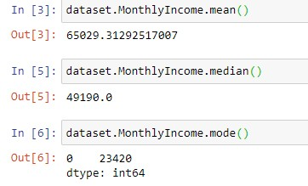

Here mean is greater than mode and median.

1. **. Since Age is normally distributed it is not the reason for Attrition.**

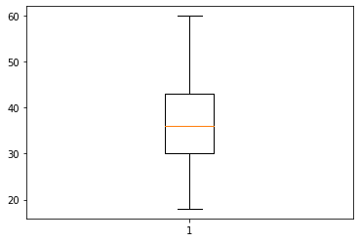

We can see that Age is almost Normally Distributed.

1. . **Since Every employee work for same Standard hours, it is not the reason for Attrition.**

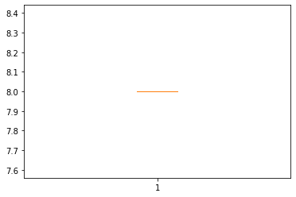

1. . **The Average Age of Employees who are working in the company is 36.**

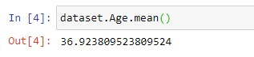

1. **. Since Average years since Last Promotion is 2.18 ,it is one of the reasons for Attrition.**

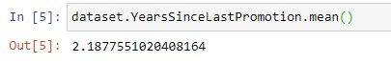

1. . **Employees who are in Job level 2 get an average monthly income of 65000.**

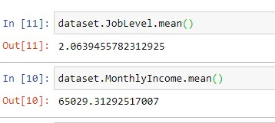

1. **. Employees who are in Job level 5 get a Salary Hike of 25%**

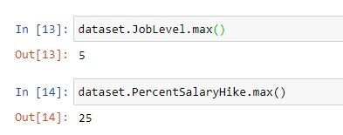

1. **. Employees who Education level 3 get a average Salary hike of 15%.**

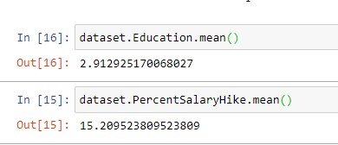

1. **. Attrition rate of male employees are greater than attrition rate of female employees.**

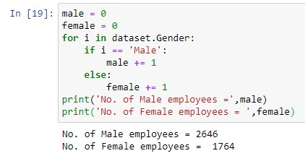

1. **. Employees who do not Business Travel are not undergoing attrition since there number is less.**

